Overview | PRACTICAL TASK 1  Critique the websites shown below, addressing the criteria listed. On page 4, apply criteria to your 2 favourite websites.
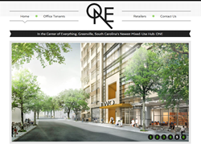 |  |  |  | GENERAL OBSERVATIONS
 |  |  |  | In general I think the design and layout is effective the use of buttons to link to each page of the site being situated along the top makes it quicker and easier to navigate the site in comparison to putting the buttons along the side of the website
URL: |  | http://onegreenville.com/
SITE FUNCTION: |  | Advertising retail and business space
NUMBER/ RANGE OF COLOURS USED |  | Green,grey,black and white
LEVEL OF INTERACTIVITY |  | Fairly interactive through clicking links on menus that take you to the main pages of the website. Additionally there are images you can hover your mouse over which give you detail such as on the office and retail space page and additional small images of the surrounding area the office and retail space is situated in.
EASE OF NAVIGATION |  | Easy to navigate through simple menu tabs which take you to each main page of the website
RECOMMENDATIONS FOR CHANGE |  | I would recommend the slideshow of photos on the homepage have buttons that you can click yourself to navigate through
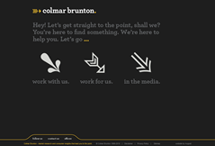 |  |  |  | GENERAL OBSERVATIONS
 |  |  |  | My first impression is that there is no clear idea of what the website function is from the homepage. Also I think the colours used are very dull and plain the website could benefit from more images or brighter backgrounds.
URL: |  | http://www.cbr.com.au/
SITE FUNCTION: |  | Australian market research agency
NUMBER/ RANGE OF COLOURS USED |  | Mainly grey,yellow and white
LEVEL OF INTERACTIVITY |  | Fairly interactive through the use of clicking on menu links to navigate the pages of the site
EASE OF NAVIGATION |  | Fairly easy navigation through the site
RECOMMENDATIONS FOR CHANGE |  | I would recommend a homepage button on each of the webpages aswell as perhaps lighter background colours and more images
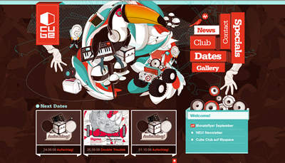 |  |  |  | GENERAL OBSERVATIONS
 |  |  |  | In general I like the design of the site I think its quite modern and different to all the general design layouts and suits the function of the site well
URL: |  | http://www.cubeclub-chemnitz.de/
SITE FUNCTION: |  | Advertise the cube club
NUMBER/ RANGE OF COLOURS USED |  | Range of bright colours such as red,blue,white
LEVEL OF INTERACTIVITY |  | Quite interactive by clicking on buttons and viewing images
EASE OF NAVIGATION |  | Easy to navigate the site by using the buttons which link to each page of the website
RECOMMENDATIONS FOR CHANGE |  | I would recommend adding a translation tool to the site as its in german
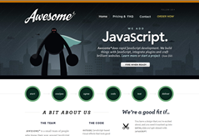 |  |  |  | GENERAL OBSERVATIONS
 |  |  |  | The site is layed out effectively for easy navigation aswell as a clear indication and understanding through the site of what the company does
URL: |  | http://www.awesomejs.com/
SITE FUNCTION: |  | A company who create and edit websites using javascript
NUMBER/ RANGE OF COLOURS USED |  | Grey,black and white mainly
LEVEL OF INTERACTIVITY |  | Fairly interactive through links to each page of the site to click on aswell as buttons you can hover over on the homepage for details of the process the company goes through for each project.
EASE OF NAVIGATION |  | Easy navigation of the site due to links to each page of the site at the top of the homepage.
RECOMMENDATIONS FOR CHANGE |  | I don’t have any recommendations for change as I think the layout and interactivity just works very effectively.

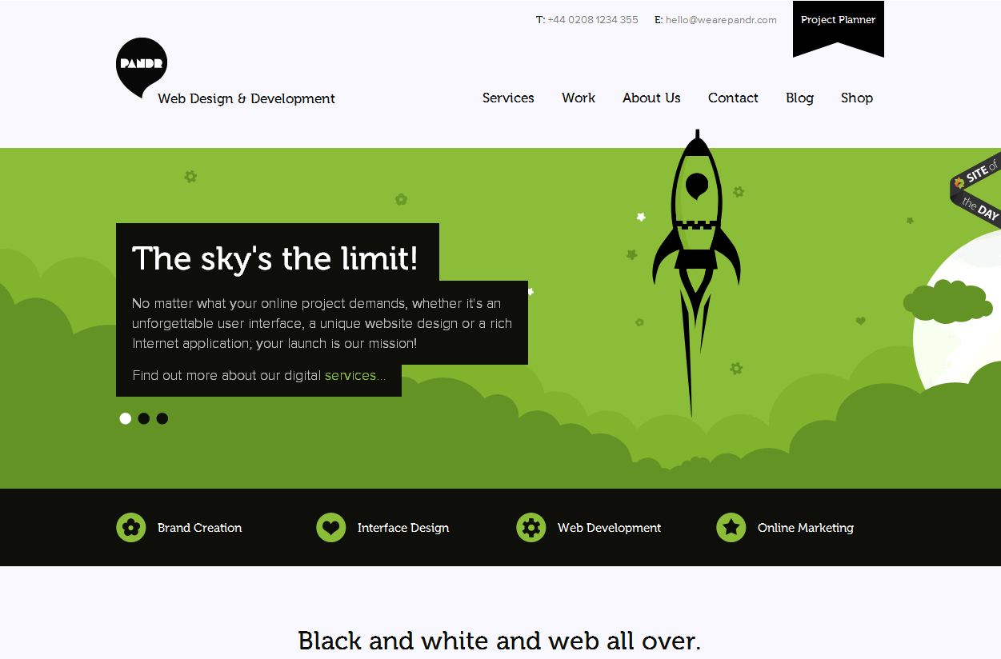 |  |  | GENERAL OBSERVATIONS
 |  |  | Good looking website with a simple design and layout for easy navigation and clear indication of what the function of the site is
URL: | http://wearepandr.com/
SITE FUNCTION: | Web Design & Development company
NUMBER/ RANGE OF COLOURS USED | Green,Black and white
LEVEL OF INTERACTIVITY | Mainly links to click on to navigate the site aswell as access external sites
EASE OF NAVIGATION | Easy to navigate the site due to simple website tabs
RECOMMENDATIONS FOR CHANGE | Allow for more of the information on each page to be seen without scrolling down the page by making the green background design smaller.
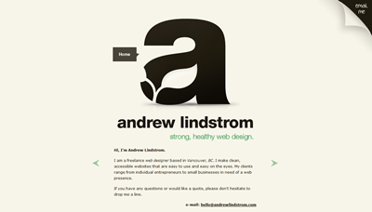 |  |  | GENERAL OBSERVATIONS
URL: | http://andrewlindstrom.com/
SITE FUNCTION: | Andrew Lindstrom freelance web designer
NUMBER/ RANGE OF COLOURS USED | Black and cream
LEVEL OF INTERACTIVITY | Very little interactivity other than arrows to click to view images of websites he has designed
EASE OF NAVIGATION | Very easy navigation as its all on one page
RECOMMENDATIONS FOR CHANGE | Add more pages to the website giving more detail on previous work he has done and the type of work and how to arrange for work to be done by him

All of the above websites were created using either CSS or Adobe Flash or a combination of the two. These examples and more are available at:
http://www.thebestdesigns.com/

APPLY CRITERIA TO YOUR OWN TWO FAVOURITE WEBSITES
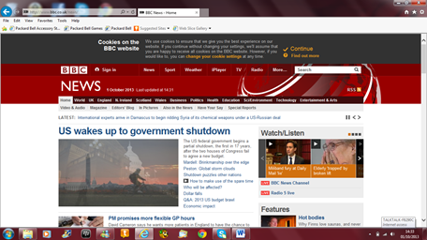 |  |  | GENERAL OBSERVATIONS
 |  |  | Good website easy navigation consistent colour theme
URL: | http://www.bbc.co.uk/news/
SITE FUNCTION: | Uk and international news
NUMBER/ RANGE OF COLOURS USED | Mainly red and white theme
LEVEL OF INTERACTIVITY | Various interactivity through clicking links scrolling through photos depending on the articles you look at
EASE OF NAVIGATION | Fairly easy through menu tabs that link to exactly what you want to view
RECOMMENDATIONS FOR CHANGE | Structure of the website layout
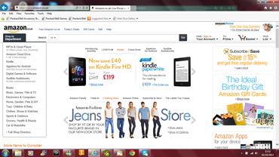 |  |  | GENERAL OBSERVATIONS
 |  |  | Good website easy to navigate and simple and effective layout
URL: | http://www.amazon.co.uk/
SITE FUNCTION: | Selling various products
NUMBER/ RANGE OF COLOURS USED | Mainly white background with black text
LEVEL OF INTERACTIVITY | Fairly interactive with links and images to click on
EASE OF NAVIGATION | Easy navigation with links to different pages depending on what you are looking for aswell as a search toolbar
RECOMMENDATIONS FOR CHANGE | I don’t have any recommendations for change I think the website works well as it is

